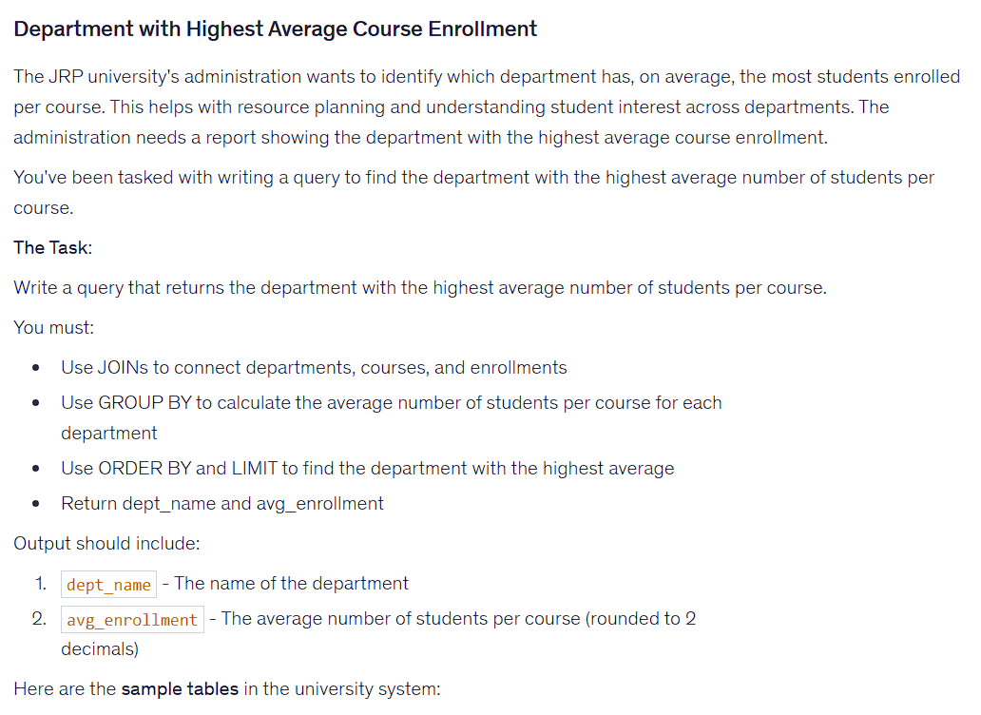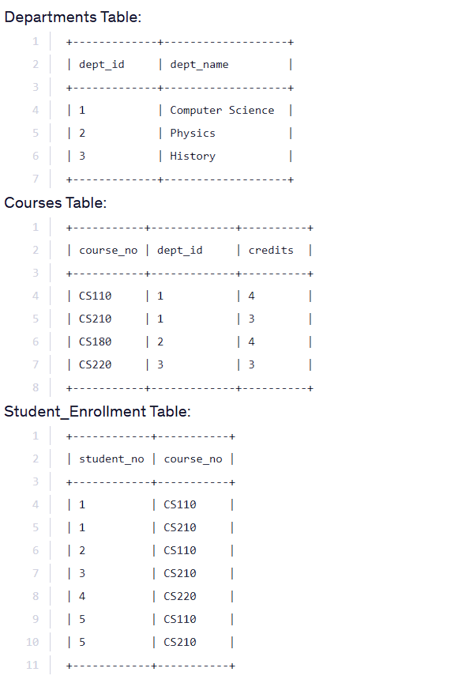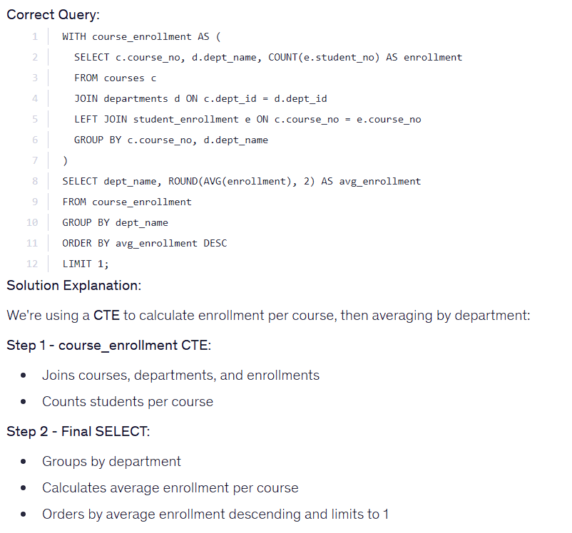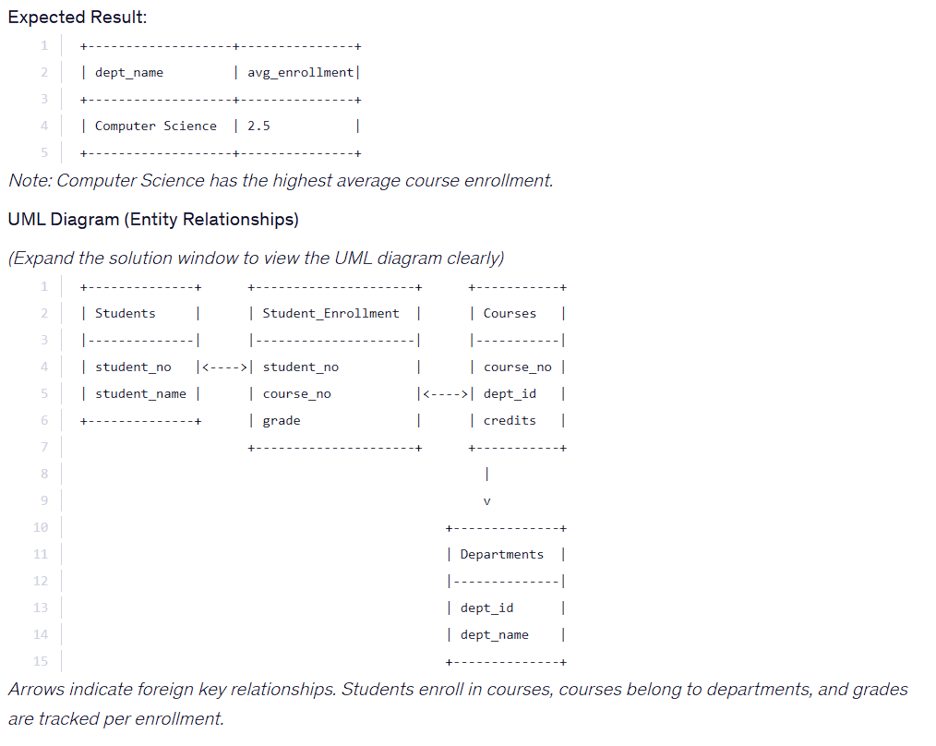

WITH course_enrollment AS (
SELECT c.course_no, d.dept_name, COUNT(e.student_no) AS enrollment
FROM courses c
JOIN departments d ON c.dept_id = d.dept_id
LEFT JOIN student_enrollment e ON c.course_no = e.course_no
GROUP BY c.course_no, d.dept_name
)
SELECT dept_name, ROUND(AVG(enrollment), 2) AS avg_enrollment
FROM course_enrollment
GROUP BY dept_name
ORDER BY avg_enrollment DESC
LIMIT 1;

